**Exercise 3.1.1**

#1 What’s gone wrong with this code? Why are the points not blue?

ggplot(data = mpg) +

geom_point(mapping = aes(x = displ, y = hwy, color = "blue"))

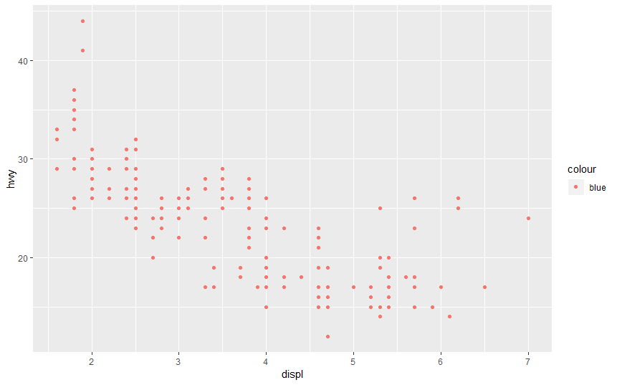

# It is not blue because the syntax is not the correct syntax for making the plot blue.

# Furthermore the points are not blue, because the color layer is specified within the aes mappings.

#Thus the framework tries to plot the color against an attribute “blue”, but this does not exist within the data.

#The correct code would be to set the color manually in the geom_point method as below.

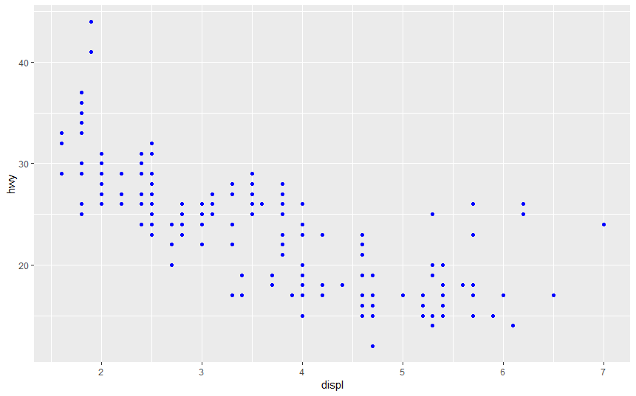

ggplot(data = mpg) +

geom_point(mapping = aes(x = displ, y = hwy), color = "blue")

#2Which variables in mpg are categorical? Which variables are continuous?

#(Hint: type ?mpg to read the documentation for the dataset). How can you see this information when you run mpg?

?mpg # Categorical variables: manufacturer model, year of manufacture,drv,hwy,fl,class,trans

#continuos variables : cyl, cty

mpg # By viewing the second row after variable name one can tell the types of categories.

#3.Map a continuous variable to color, size, and shape. How do these aesthetics behave differently for categorical vs. continuous variables?

#Using a continous variable with the color aesthetic

ggplot (data=mpg)+

geom_point(mapping=aes(x=displ,y=hwy,color=displ)) #The legend has one colour whose intensity goes on reducing with with increase in the continous variable

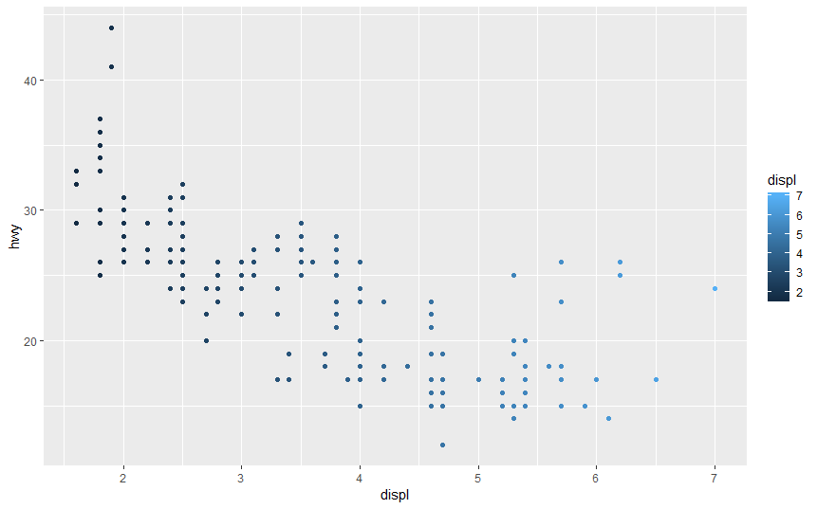

#Using a continous variable with the shape aesthetic

ggplot (data=mpg)+

geom_point(mapping=aes(x=displ,y=hwy,shape=displ)) # A continuos variable can not be mapped into a shape

#Using a continous variable with the size aesthetic

ggplot (data=mpg)+

geom_point(mapping=aes(x=displ,y=hwy,size=displ)) # Size of the continous variable goes on increasing as the continius variable is increasing

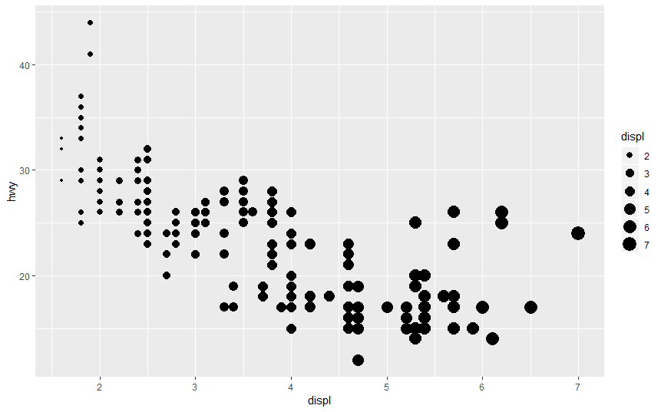

# a continuos variables: one should only use siz and color aesthetics

# Categorical all the 3 aesthetics size, shape,color can be used.

#4.What happens if you map the same variable to multiple aesthetics?

ggplot(data = mpg) +

geom_point(mapping = aes(x = displ, y = hwy, color = cyl, size = cyl))

#Simply both layers are applied

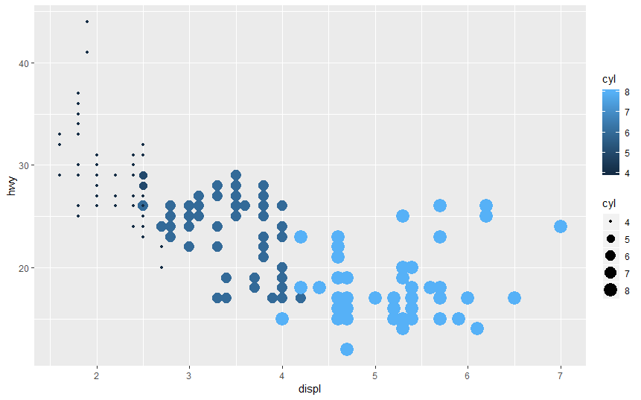

#5.What does the stroke aesthetic do? What shapes does it work with? (Hint: use ?geom_point)

#The stroke aesthetic seems to adjust the plotted object thickness e.g

?geom_point

ggplot (data=mpg)+

geom_point(mapping=aes(x=displ,y=hwy),stroke=5)

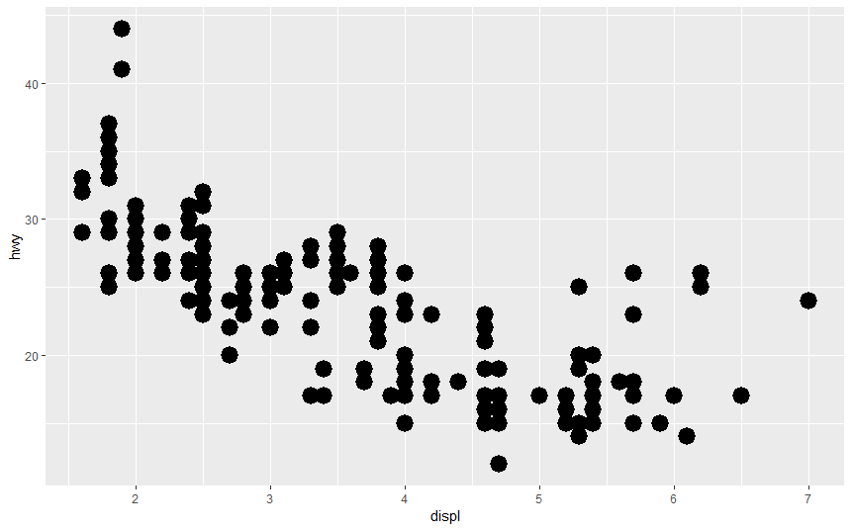

#6. What happens if you map an aesthetic to something other than a variable name, like aes(colour = displ < 5)?

ggplot(data=mpg)+

geom_point(mapping=aes(x=displ,y=hwy,color=displ<5))

#This plot shows color codes for values of displ that fullfil the condition displ

